***Project Report***

***On­­­***

**Hangman Game**

**Submitted for the requirement of**

**Industrial training Project course**

BACHELOR OF ENGINEERING

**COMPUTER SCIENCE & ENGINEERING**



**Submitted to : Submitted by:**

**Vikash Sagar kumar aakarshan (18BCS6640)**

**DEPARTMENT OF COMPUTER SCIENCE & ENGINEERING**

**CHANDIGARH UNIVERSITY, GHARUAN**

**Certificate**

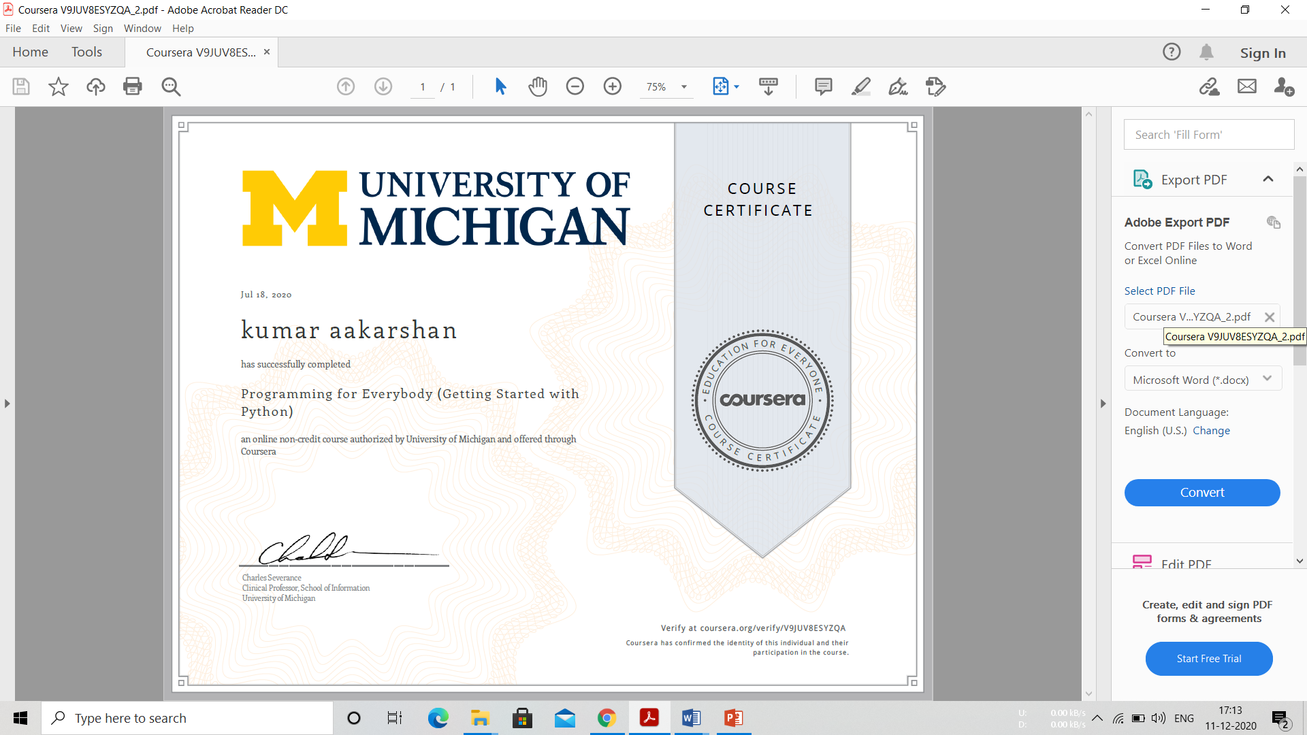

**Introduction:**

The purpose of the program is to have some fun at work when you’ve finished all of your projects and you do not have internet access or games! There are no calculations in the code, but it did require a lot of loops. I first had to set ranges that would reset every time the game started. I then set a variable for the words to guess as a message and set a limit for the number of turns allowed before the player loses. The fun part of the code was inputting what words to use in the game, and the hint that goes with it. To do this I used If-ElseIf- Else statements and a random number generator that would guess a random number between 0 and 10, and whatever number chosen would determine what word was to be guessed. Now I had to implement loops that would:

1. Allow the user to use the cancel button
2. Check through the entire word to see if guess was correct
3. Display the hangman after every missed guess
4. Black Out letters already guessed
5. Stop the game if word was figured out.
6. Stop the game if player loses and display the answer

This code was very challenging for me not because the loops were difficult, but because the way to think through the game was a task my brain had never tried. And when I start work this summer I have something to do in my down time!

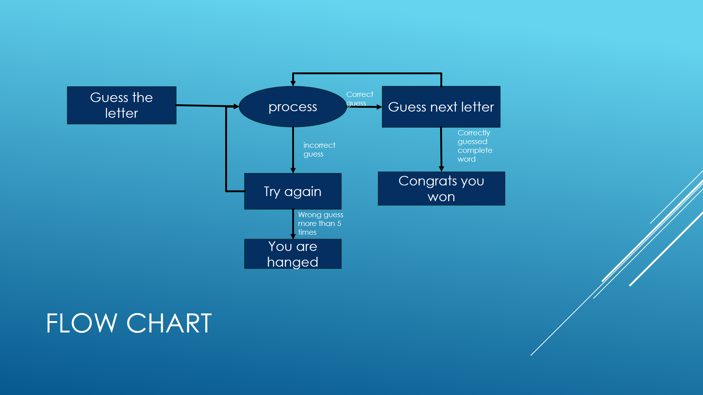

**Code**

import random

import time

print("\nWelcome to Hangman game by Kumar aakarshan\n")

name = input("input your name: ")

print("Hello " + name + "! All The Very Best!")

time.sleep(2)

print("The game is about to begin!\n Let's play Hangman!")

time.sleep(4)

def main():

global count

global display

global word

global already_guessed

global length

global play_game

words_to_guess = ["aakarshan","border","image","film","promise","kids","lungs","doll","rhyme","damage"

,"plants"]

word = random.choice(words_to_guess)

length = len(word)

count = 0

display = '_' * length

already_guessed = []

play_game = ""

def play_loop():

global play_game

play_game = input("Do You want to play again? y = yes, n = no \n")

while play_game not in ["y", "n","Y","N"]:

play_game = input("Do You want to play again? reply y = yes, n = no \n")

if play_game == "y":

main()

elif play_game == "n":

print("Thanks For Playing! We expect you back again!")

exit()

def hangman():

global count

global display

global word

global already_guessed

global play_game

limit = 5

guess = input("This is the Hangman Word: " + display + " Enter your guess: \n")

guess = guess.strip()

if len(guess.strip()) == 0 or len(guess.strip()) >= 2 or guess <= "9":

print("Invalid Input, Try a letter\n")

hangman()

elif guess in word:

already_guessed.extend([guess])

index = word.find(guess)

word = word[:index] + "_" + word[index + 1:]

display = display[:index] + guess + display[index + 1:]

print(display + "\n")

elif guess in already_guessed:

print("Try another letter.\n")

else:

count += 1

if count == 1:

time.sleep(1)

print(" _____ \n"

" | \n"

" | \n"

" | \n"

" | \n"

" | \n"

" | \n"

"__|__\n")

print("Wrong guess. " + str(limit - count) + " guesses remaining\n")

elif count == 2:

time.sleep(1)

print(" _____ \n"

" | | \n"

" | |\n"

" | \n"

" | \n"

" | \n"

" | \n"

"__|__\n")

print("Wrong guess. " + str(limit - count) + " guesses remaining\n")

elif count == 3:

time.sleep(1)

print(" _____ \n"

" | | \n"

" | |\n"

" | | \n"

" | \n"

" | \n"

" | \n"

"__|__\n")

print("Wrong guess. " + str(limit - count) + " guesses remaining\n")

elif count == 4:

time.sleep(1)

print(" _____ \n"

" | | \n"

" | |\n"

" | | \n"

" | O \n"

" | \n"

" | \n"

"__|__\n")

print("Wrong guess. " + str(limit - count) + " last guess remaining\n")

elif count == 5:

time.sleep(1)

print(" _____ \n"

" | | \n"

" | |\n"

" | | \n"

" | O \n"

" | /|\ \n"

" | / \ \n"

"__|__\n")

print("Wrong guess. You are hanged!!!\n")

print("The word was:",already_guessed,word)

play_loop()

if word == '_' * length:

print("Congrats! You have guessed the word correctly!")

play_loop()

elif count != limit:

hangman()

main()

hangman()

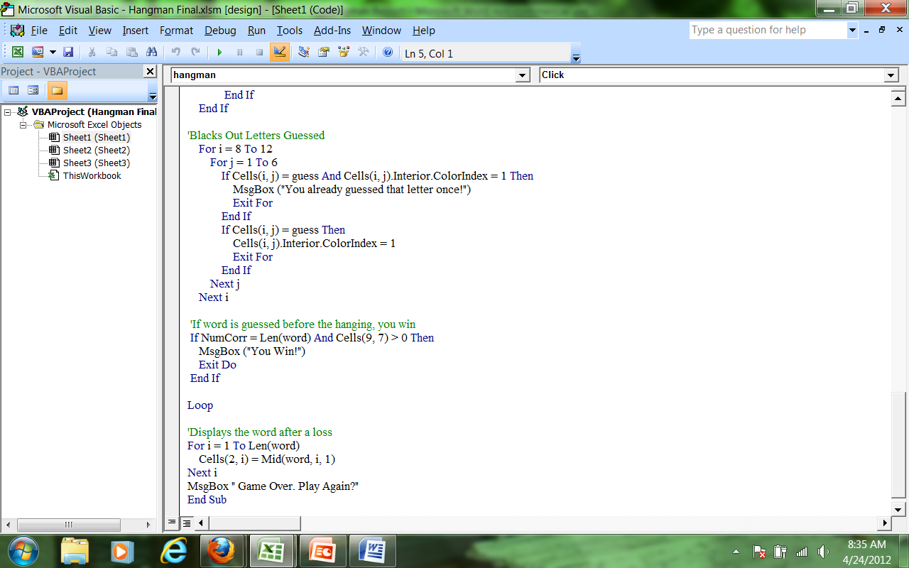

Inputs

Guess a Letter

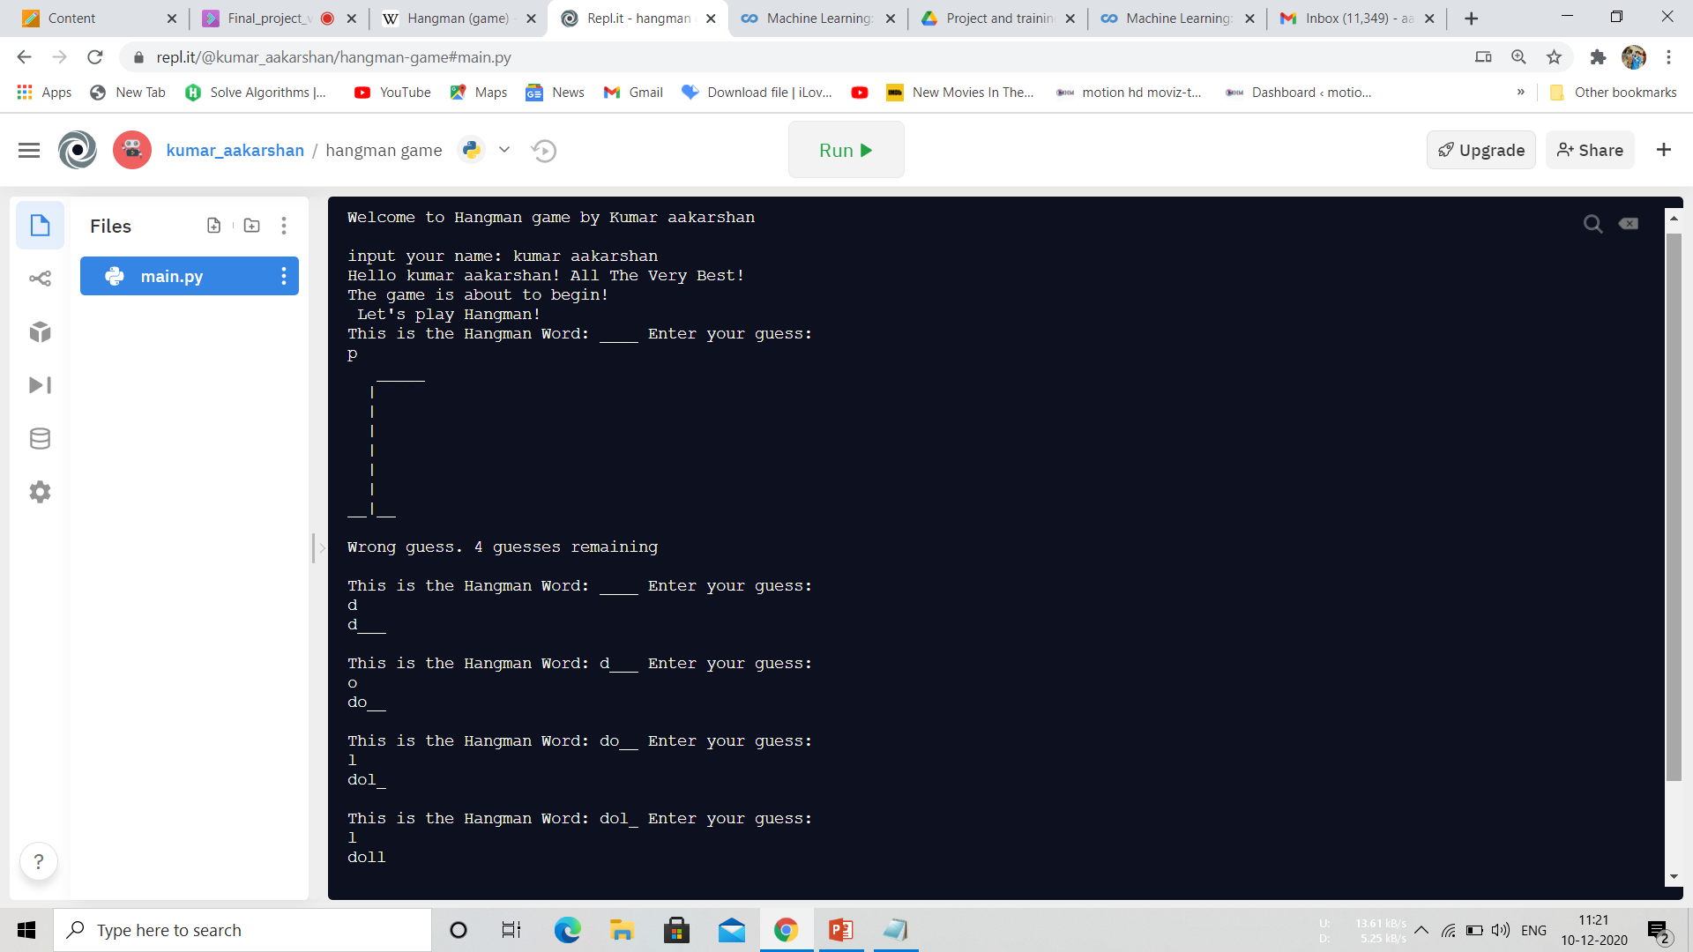

Wrong Letter Guessed

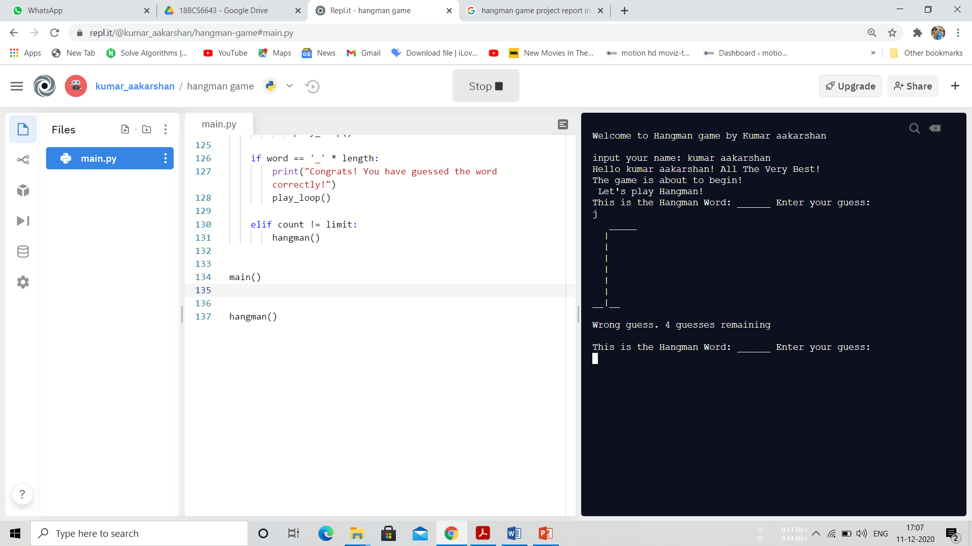

Finding all the right Letters

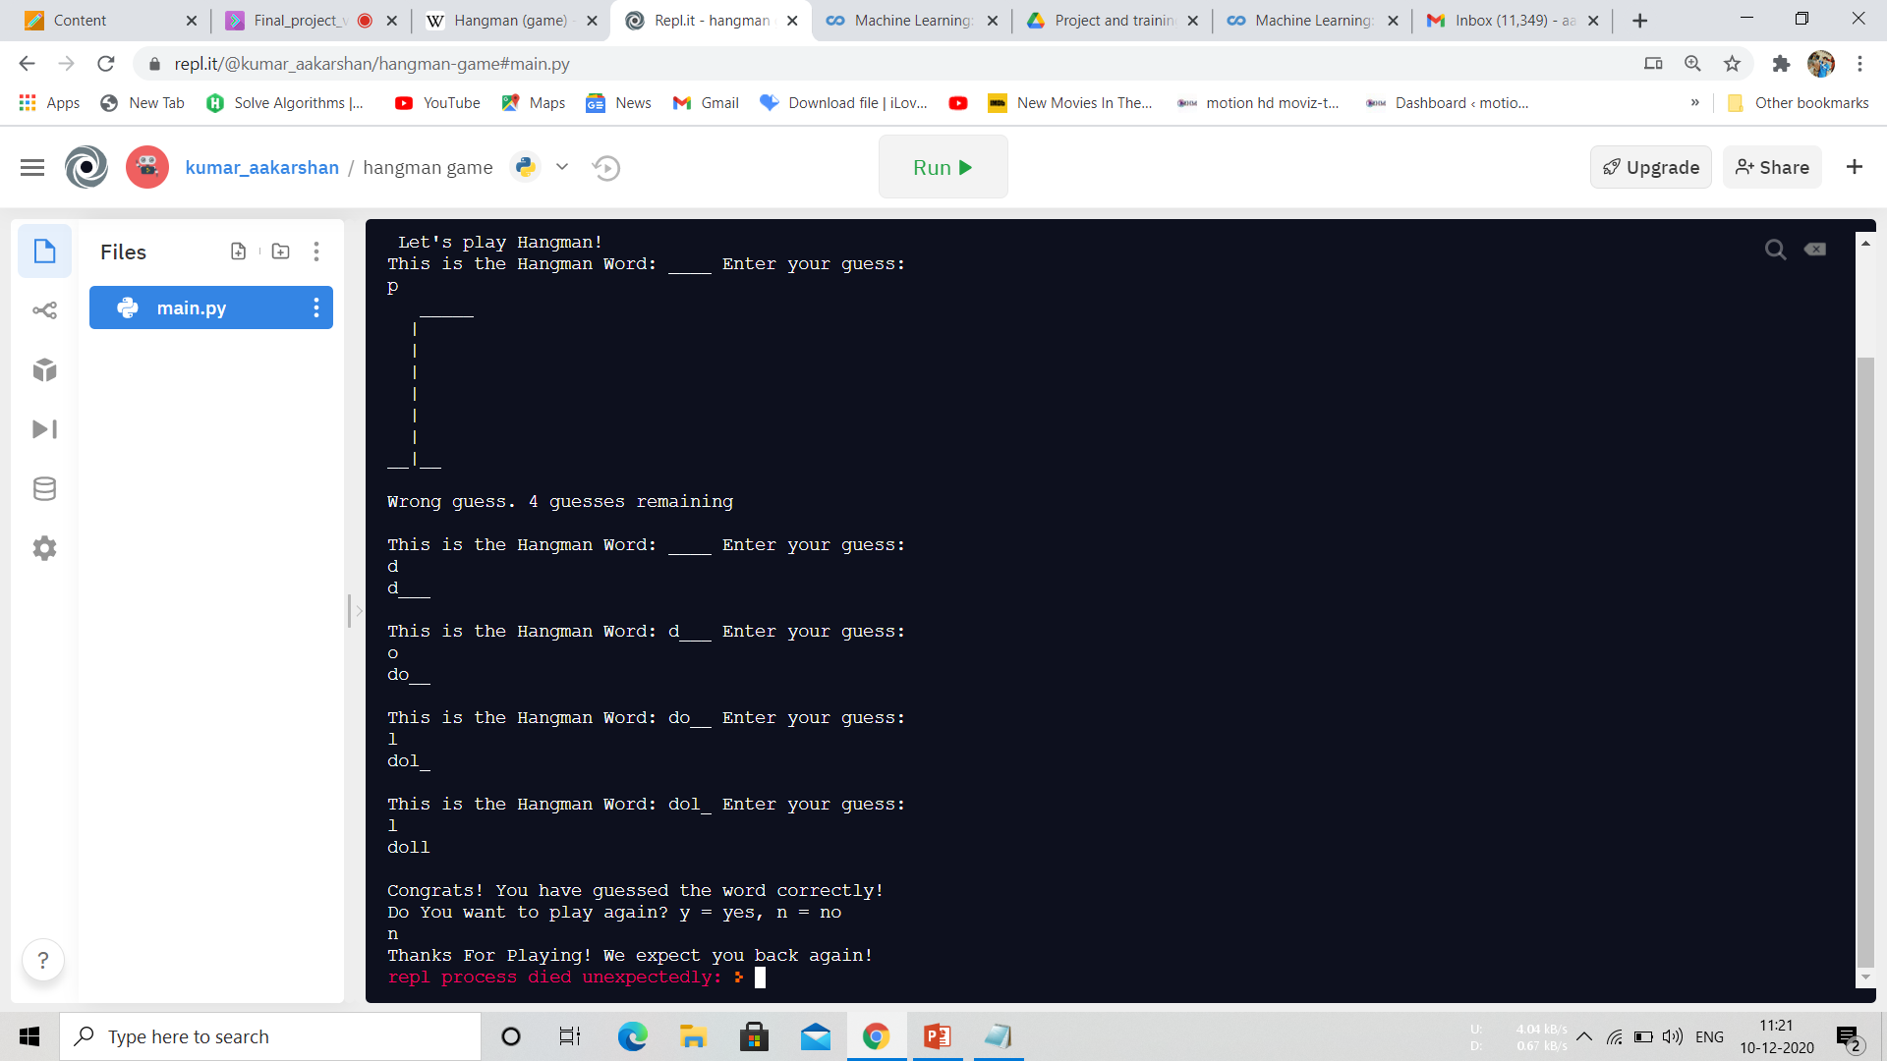

Hangman

